  - Random Forest
- What is the overall performance of the model? → 0.90(Accuracy)
- What the correct classification is of not purchased? → 0.92(Recall (0))
- What the correct classification is of purchased? → 0.88(Recall(1))
- What is the correct prediction of purchased customers? → 0.86(Precision(1))
- What is the correct prediction of not purchased customers? → 0.93(Precision(0))

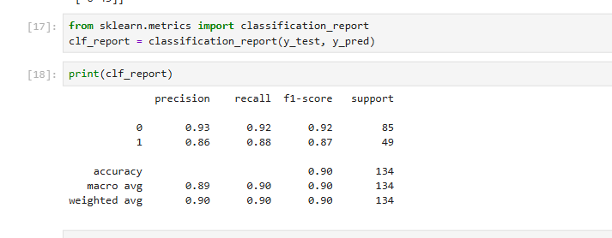
  - Decision Tree
- What is the overall performance of the model? → 0.87(Accuracy)
- What the correct classification is of not purchased? → 0.89(Recall(0))
- What the correct classification is of purchased? → 0.84(Recall(1))
- What is the correct prediction of purchased customers? → 0.82(Precision(1))
- What is the correct prediction of not purchased customers? →0.90(Precision(0))

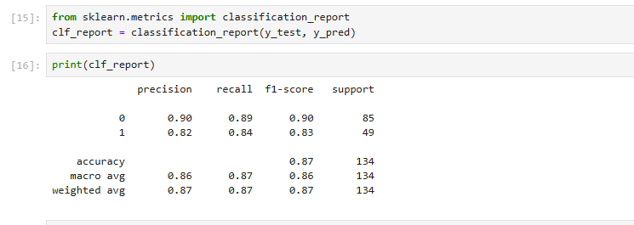
  - Support Vector Machine(SVM)
- What is the overall performance of the model? → 0.78(Accuracy)
- What the correct classification is of not purchased? → 0.96(Recall(0))
- What the correct classification is of purchased? → 0.47(Recall(1))
- What is the correct prediction of purchased customers? → 0.88(Precision(1))
- What is the correct prediction of not purchased customers? →0.76(Precision(0))

